Touchstones Monthly Themes for 2021-2021

Annual Theme Repairing the World
In Judaism, it is called Tikkun Olam, meaning “repair of the world.” Not that we are divine or omnipotent, but we can all be involved in co-creation with the powers for goodness. Repair is necessary because the world & society have been damaged both accidentally and intentionally. Whether climate change, poverty, racism, and more, the world calls out for justice and compassion. Let us respond.

September 2021 Reason
Whether in science, philosophy, law, and so many other fields in the academy and in the “real” world, reason has been and is a powerful tool in the search for truth and the accumulation of wisdom. Yet, given fake news, alternative facts, falsehoods, conspiracy theories, and deception, reason is under assault from many places.
Image by Gerd Altmann from Pixabay

October 2021 Reverence
The world shaking and world changing revelation for Albert Schweitzer was “reverence of life” as a first principle in 1915 while on a barge on the Ogowe River as the barge made its way through a herd on hippopotamuses. Not just reverence for humanity, as important as that is, but reverence for all life on the planet. It is out of such reverence that the desire to repair the world is born.
Photo by Tengyart on Unsplash

November 2021 Non-Violence
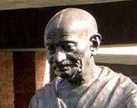Universalist and Unitarian minister Adin Ballou’s and Unitarian Henry David Thoreau’s writings influenced Leo Tolstoy’s, Mahatma Gandhi’s, and Rev. Dr. Martin Luther King’s philosophy and practice of non-violence. The commitment to non-violence is essential to oppose and subvert a culture of violence that is so damaging. Non-violence is an essential tool in the work to repair the world.
Image by Rutvik Koshti from Pixabay

December 2021 Healing
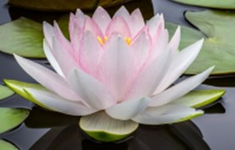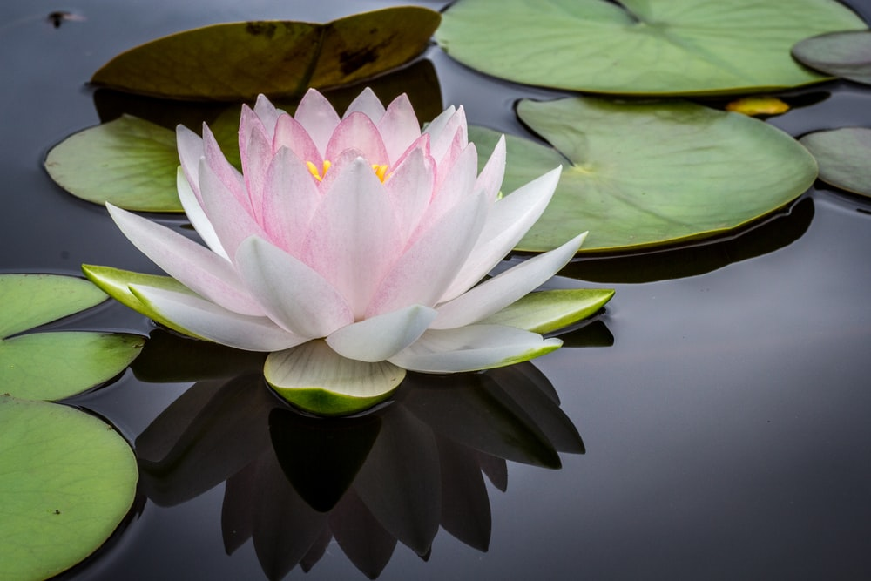Ian MacLaren wrote, “Be kind; everyone you meet is fighting a hard battle.” Since this is true, we are all in need of healing, and we are all called to be healers. While healing is physical, it is also emotional and spiritual. In some cases, while physical healing may not be possible, emotional and spiritual healing become even more important. Healing is the “repair” of the self and the world.
Photo by Jay Castor on Unsplash

January 2022 Renewal
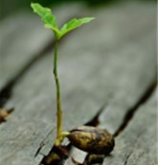Renewal is a necessity built into the fabric of life. It is one aspect of the repair of the world. Winter fallowness is a process of renewal giving birth to another springtime. Whether we relax, rest, or sleep, renewal should be the result. When it is not, more is needed physically, mentally, emotionally, and/or spiritually to return us to wholeness. Things fall apart and must be put back together again.
Image by congerdesign from Pixabay

February 2022 Power
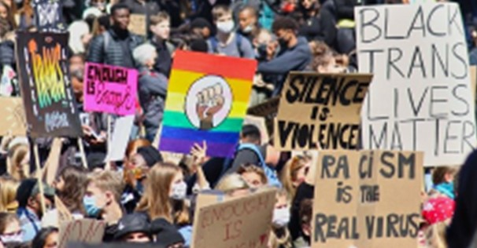In 1857, Frederick Douglass said, “Power concedes nothing without a demand. It never did and it never will.” Thus, a struggle will be required by each generation to renew, repair, and/or reclaim things like democracy, equality, liberty, freedom, and other rights that can be denied or undermined. Our tools of power include reason, non-violence, and courage to oppose hatred, violence, deceit, and more.
Photo by Priscilla Du Preez on Unsplash

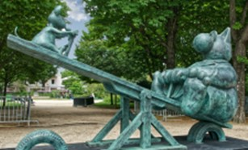March 2022 Balance
Life depends on balance. It is the principle of yin and yang. Dark and light, hot and cold, wet and dry. Sometimes balance is easy, like being on a seesaw. At other times, it is a high-wire act with all the risk that entails when things have gone dangerously out of balance. Repair of the world sometimes involves the work to restore balance, especially when dis-ease is rampant.
Photo by Pascal Bernardon on Unsplash

April 2022 Theological Reflection
Theological reflection is an essential process to identify first principles, clarify values, take seriously that which we do not believe, explore those ideas that make us uncomfortable and/or challenge us, and ensure that our beliefs are life enhancing. As Rilke said, sometimes it is necessary to live the questions in order to experience the answer on some distant day. Theological reflection is a life-long endeavor.
Image by lil_foot_ from Pixabay

May 2022 Courage
The root of courage is corage, the Old French word for heart (as the seat of emotions). In Middle English, uses included bold corage meaning “brave heart.” As Aristotle said, “Courage is the first of human virtues because it makes all others possible.” Courage is essential to wield power non-violently in opposition to all that diminishes or negates life. Courage makes repair of the world possible.
Photo by Sharon McCutcheon on Unsplash

June 2022 Prophetic Imperative
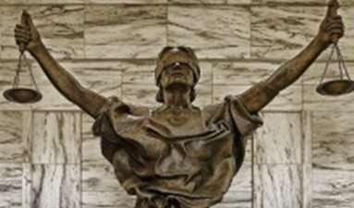The prophetic imperative is the call to justice work, the call to the repair of the world. The foundation for this was done by the Rev. Richard Gilbert in which he explored the connections between spirituality and social action. As the Hebrew prophet Micah said, we are called “to do justice, and to love mercy, and to walk humbly with …God?” Clearly, the repair of the world is a prophetic imperative.
Image by David Mark from Pixabay

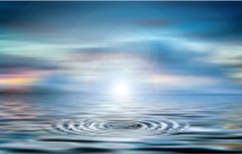July 2022 Circle of Life
As Chief Black Elk said, “Everything the Power of the World does is done in a circle.” Yin and yang, these complementary opposites are expressed in a circle. We live in circles within circles. The rotation of the Milky Way, the solar year, the seasons, solstice and equinox, the waxing and waning of the moon, the rotation of earth that gives us night and day, and birth and death. The circle of life, our life.
Image by Gerd Altmann from Pixabay

August 2022 Ambiguity/Paradox
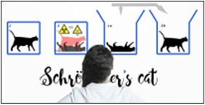We could insist on straight lines, alternative facts, unchanging clarity, and comforting deceit to hold back time and change, and everything else that induces fear and anxiety in the world. Instead, we live with ambiguity and embrace paradox because this leads to truth, even if tentative, and wisdom instead of certainty. All of the above helps us. All of the above encourages us to continue to repair the world.
Image by Gerd Altmann from Pixabay

